**RAJALAKSHMI ENGINEERING COLLEGE**

**RAJALAKSHMI NAGAR, THANDALAM – 602 105**



|  |
| --- |
| **CS23A34**  **USER INTERFACE AND DESIGN LAB** |
| **Laboratory Observation NoteBook** |

|  |
| --- |
| **Name :** VISHWA J  **Year/Branch/Section :** II/CSE/D  **Register No. :** 230701384  **Semester :** IV  **Academic Year:** 2024-25 |

**Ex. No.**  **: 3a**

**Register No. : 230701384**   **Name : VISHWA J**



**Create a prototype with familiar and unfamiliar navigation**

**elements. Evaluate ease of use with different user groups**

**using proto.io**

**AIM:**

The aim is to develop a prototype incorporating both familiar and novel navigation elements and assess usability among diverse user groups using Proto.io.

**PROCEDURE:**

Tool Link: https://proto.io/

**Step 1:** **Sign Up and Log In**

1. Go to proto.io.

2. Sign up for a new account or log in if you already have one.

**Step 2: Create a New Project**

1. Click on "Create New Project."

2. Give your project a name (e.g., "Simple App Example").

3. Select the device type (e.g., Mobile - iPhone X).

4. Click "Create" to start the project.

**Step 3:** **Design the Home Screen**

1. **Add a New Screen:**

○ Click on the "+" button in the left panel to add a new screen.

○ Choose "Blank" and name it "Home."

2. **Add Elements to the Home Screen:**

○ Drag a "Header" widget from the "Widgets" panel to the top of the screen.

○ Double-click the header to edit the text and change it to "Home Screen."

○ Drag a "Button" widget onto the screen. Place it in the center.

○ Double-click the button to edit the text and change it to "Go to Profile."

3. **Add Interaction:**

○ Select the button and click on the "Interactions" tab on the right panel.

○ Click "+ Add Interaction."

○ Set the trigger to "Tap/Click."

○ Set the action to "Navigate to Screen" and choose "New Screen."

○ Create a new screen and name it "Profile."

**Step 4: Design the Profile Screen**

1. **Add Elements to the Profile Screen:**

○ On the newly created Profile screen, drag a "Header" widget to the top of the screen.

○ Double-click the header to edit the text and change it to "Profile Screen."

○ Drag an "Image" widget onto the screen. Place it below the header.

○ Double-click the image to upload a profile picture or any placeholder image.

○ Drag a "Text" widget onto the screen to add some profile information

(e.g., "John Doe, Software Engineer").

2. **Add Back Button:**

○ Drag a "Button" widget onto the screen.

○ Double-click the button to edit the text and change it to "Back to Home."

3. **Add Interaction:**

○ Select the button and click on the "Interactions" tab on the right panel.

○ Click "+ Add Interaction."

○ Set the trigger to "Tap/Click."

○ Set the action to "Navigate to Screen" and choose "Home."

**Step 5: Preview the Prototype**

1. Click on the "Preview" button in the top-right corner.

2. Interact with the prototype by clicking on the buttons to navigate between the

Home and Profile screens.

**Step 6: Share the Prototype**

1. Click on the "Share" button in the top-right corner.

2. Copy the shareable link and send it to others for feedback.

**Output :**

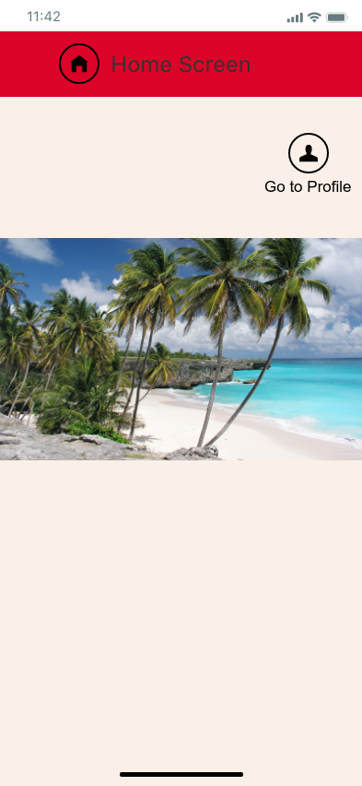 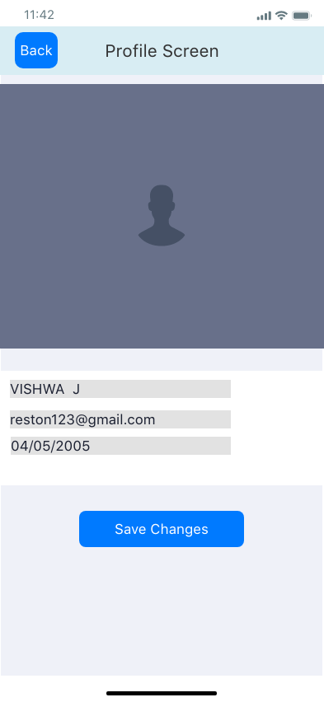

**Result :**

Hence, creating a prototype with familiar and unfamiliar navigation and using different user groups using prto.io has been successfully executed.